**IDEATION PHASE**

**BRAINSTORM & IDEA PRIORITIZATION**

|  |  |
| --- | --- |
| Date | 15 September 2022 |
| Team ID | PNT2022TMID15455 |
| Project Name | Early Detection of Chronic Kidney Disease using Machine Learning |
| Maximum Marks | 4 Marks |

**Brainstorm & Idea Prioritization Template:**

**Step-1: Team Gathering, Collaboration and Select the Problem Statement**

**Step-2: Brainstorm, Idea Listing and Grouping**

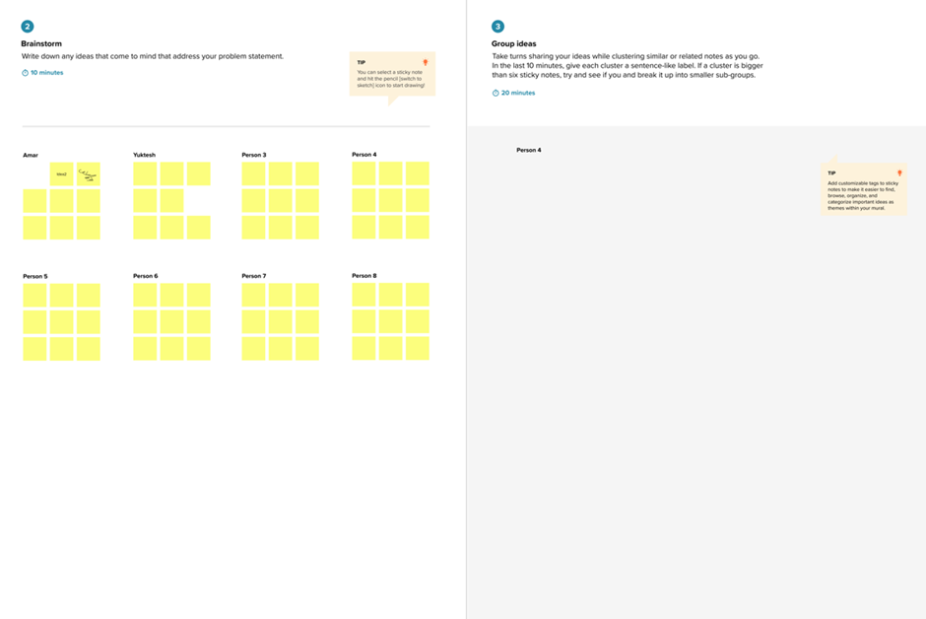

**Avoid unnecessary money loss**

**Professionals find it easy to identify the disease**

**Suggest the suitable algorithm for kidney diagnosis**

**PRADEEP M M**

**KAVIYA N**

**ABIRAMI V**

**BHAVA DHARANI G**

Avoid noisy data values

Find out best fit algorithm

More number of patients result can be processed in a short span of time

Efficient way to identify the disease

Reduce manual diagnosis

Avoid unwanted error occurred in the accuracy

Suggest the best algorithm

User-friendly

Promote early diagnosis

Early detection of kidney disease

Previous records analysis

Disease Diagnosis

**Step-3: Idea Prioritization**

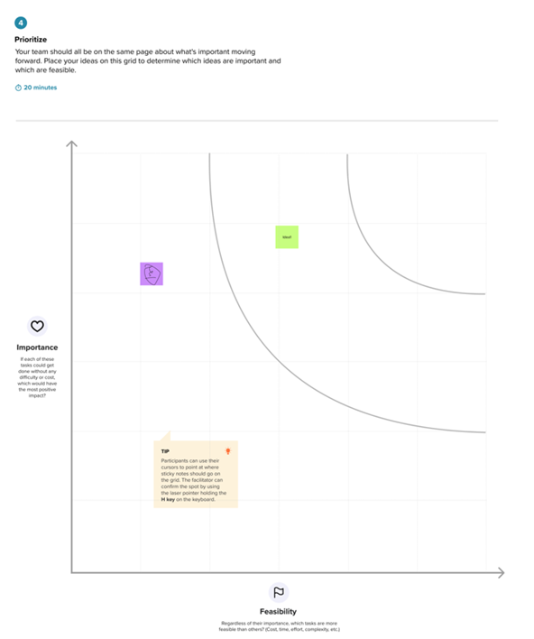

**Provide more accuracy**

**Early identification of chronic kidney disease**

**Suggest accurate algorithm**